**MACHINE LEARNING BASED SPAM COMMENTS DETECTION ON YOUTUBE**

|  |  |
| --- | --- |
| **CONTENT** | **PAGE NO** |
| **Abstract** |  |
| **1.INTRODUCTION** |  |
| 1.1 Motivation |  |
| 1.2 Problem Statement |  |
| 1.3 Objective of the Project |  |
| 1.4 Scope |  |
| 1.5 Project Introduction |  |
| **2.LITERATURE SURVEY** |  |
| 2.1 Related Work |  |
| **3. SYSTEM ANALYSIS** |  |
| 3.1 Existing System |  |
| 3.2 Disadvantages |  |
| 3.3 Proposed System |  |
| 3.4 Advantages |  |
| 3.5 work Flow of Proposed system |  |
| **4. REQUIREMENT ANALYSIS** |  |
| 4.1Function and non-functional requirements |  |
| 4.2 Hardware Requirements |  |
| 4.3 Software Requirements |  |
| 4.4 Architecture |  |
| **5. SYSTEM DESIGN** |  |
| 5.1 Introduction of Input design |  |
| 5.2 UML Diagram(class, use case, sequence, collaborative, deployment, activity, ER diagram and Component diagram) |  |
| 5.3 Data Flow Diagram |  |
| **6. IMPLEMENTATION AND RESULTS** |  |
| 6.1 Modules |  |
| 1. **PYTHON ENVIRONMENT** |  |
| 7.1 Software Installation |  |
| 7.2 About Python Language |  |
| 1. **SYSTEM STUDY AND TESTING** |  |
| 8.1 Feasibility study |  |
| 8.2 Types of test |  |
| **9. CONCLUSION** |  |
| **10. FUTURE ENHANCEMENT** |  |
| **11. REFERENCES** |  |

**ABSTRACT:**

The rise of spam comments on platforms like YouTube has become a significant concern, as they not only hinder genuine user engagement but also pose serious risks to users' safety and privacy. Machine Learning (ML) offers a powerful solution to combat spam comments by automating the process of detecting and preventing them. With the ability to analyze vast amounts of data and patterns, ML algorithms can effectively distinguish between legitimate comments and those that are spam. One of the commonly employed approaches in ML for spam comment detection is the Naive Bayes classification algorithm. Naive Bayes is a probabilistic algorithm that calculates the likelihood of a comment being spam based on its characteristics and the occurrence of specific keywords or phrases that are typical of spam content. By training the algorithm on a labeled dataset of spam and non-spam comments, it can learn to recognize patterns and generalize its understanding to new, unseen comments. Achieving a detection accuracy of 92.78% is indeed promising, but researchers and developers continue to explore other ML techniques and combinations to further improve the accuracy and robustness of spam comment detection systems. Ensemble methods, deep learning, and natural language processing (NLP) techniques are among the advanced ML approaches gaining attention in this domain. One crucial aspect of an effective spam detection system is its adaptability and responsiveness to emerging spam tactics.

**Keywords**: ML evaluation, ML techniques , Naïve bayes , decision tree , MLP classifier .

1. **INTRODUCTION**

**1.1 Motivation:**

Machine Learning-based Spam Comment Detection on YouTube aims to enhance user experience by automatically identifying and filtering out irrelevant and malicious comments. By leveraging advanced algorithms, this technology helps maintain a safe and engaging environment, fostering genuine interactions while mitigating the harmful impact of spam, promoting meaningful engagement and interaction among users.

**1.2 Problem Statement:**

1. Objective: Develop a robust machine learning solution for detecting and filtering out spam comments on YouTube videos to enhance user experience and maintain a healthy and engaging online community.

2. Challenge: YouTube's vast user-generated content and evolving spam tactics pose a challenge in accurately identifying diverse forms of spam comments, including irrelevant promotions, malicious links, and offensive content, while minimizing false positives to preserve legitimate comments.

3. Solution: Create an effective spam comment detection model by leveraging advanced natural language processing (NLP) techniques and supervised machine learning algorithms on a labeled dataset, aiming to achieve a high precision and recall balance to ensure accurate identification of spam comments and reduce their visibility on YouTube videos.

**1.3 Objective of the Project:**

The objective of this project is to develop a machine learning-based system for accurately detecting and filtering out spam comments on YouTube videos, enhancing user experience by promoting genuine interactions and safeguarding the platform's content quality and integrity.

**1.4 Scope:**

The project aims to develop a Machine Learning model for detecting spam comments on YouTube videos. By analyzing comment content and user interactions, the model enhances content quality, user experience, and platform credibility, contributing to a safer and more engaging online community.

**1.5 Project Introduction:**

Machine Learning (ML) has revolutionized various domains, and its application to online platforms is notably transforming content moderation. One such prominent arena is the detection of spam comments on YouTube. With the exponential growth of user-generated content, ensuring a safe and engaging environment for users has become a paramount concern. ML-based spam comments detection on YouTube leverages advanced algorithms to swiftly and accurately identify and filter out undesirable and misleading comments. This innovative approach harnesses the power of ML to automatically learn patterns and characteristics of spam comments from vast datasets. By analyzing linguistic cues, syntactical irregularities, and user engagement metrics, ML models can distinguish between genuine and spam comments. These models are trained on diverse samples of comments, enabling them to adapt and evolve alongside evolving spam tactics. The impact of ML-based spam comments detection is multifaceted. It not only safeguards the user experience by curbing the visibility of spam but also enhances the authenticity and credibility of discussions. By reducing the noise generated by spam, the quality of interactions among users is elevated, fostering meaningful conversations and community growth. While ML-based detection is an effective tool, continuous refinement and updates are essential to stay ahead of sophisticated spam techniques. Collaborative efforts between ML engineers and domain experts are crucial to fine-tune models, ensuring minimal false positives and negatives. As YouTube continues to evolve as a dynamic platform, Machine Learning plays a pivotal role in maintaining a vibrant, safe, and trustworthy online ecosystem.

1. **LITERATURE SURVEY**

**2.1 Related Work:**

**[1] Sah, U. K., & Parmar, N. (2017). An approach for Malicious Spam Detection in Email with comparison of different classifiers.** In this paper, today one of the cheapest form of communication in the world is email, and its simplicity makes it vulnerable to many threats. One of the most important threats to email is spam; unsolicited email, especially when advertising agency send a mass mail. Spam email may also include malware as scripts or other executable file. Sometimes they also consist harmful attachments or links to phishing websites. This malicious spam threatens the privacy and security of large amount of sensitive data. Hence, a system that can automatically learn how to classify malicious spam in email is highly desirable. In this paper, we aim to improve detection of malicious spam through feature selection. We propose a model that employs a novel dataset for the process of feature selection, a step for improving classification in later stage. Feature selection is expected to improve training time and accuracy of malicious spam detection. This paper also shows the comparison of various classifier used during the process

**[2] Alberto, T. C., Lochter, J. V., & Almeida, T. A. (2015, December). Tubespam: Comment spam filtering on youtube. In Machine Learning and Applications (ICMLA), 2015 IEEE 14th International Conference on (pp. 138-143). IEEE.** In this paper, The proﬁtability promoted by Google in its brand

new video distribution platform YouTube has attracted an

increasing number of users. However, such success has also

attracted malicious users, which aim to self-promote their videos

or disseminate viruses and malwares. Since YouTube offers

limited tools for comment moderation, the spam volume is

shockingly increasing which lead owners of famous channels to

disable the comments section in their videos. Automatic comment

spam ﬁltering on YouTube is a challenge even for established

classiﬁcation methods, since the messages are very short and

often rife with slangs, symbols and abbreviations. In this work, we

have evaluated several top-performance classiﬁcation techniques

for such purpose. The statistical analysis of results indicate that,

with 99.9% of conﬁdence level, decision trees, logistic regression,

Bernoulli Na¨

ıve Bayes, random forests, linear and Gaussian SVMs

are statistically equivalent. Based on this, we have also offered

the TubeSpam

**[3] Alsaleh, M., Alarifi, A., Al-Quayed, F., & Al-Salman, A. (2016). Combating comment spam with machine learning approaches. Proceedings - 2015 IEEE 14th International Conference on Machine Learning and Applications, ICMLA 2015, 295–300. https://doi.org/10.1109/ICMLA.2015.192.** The paper addresses the significant issue of comment spam within online platforms and introduces a novel approach utilizing machine learning techniques for its detection and mitigation.

The authors acknowledge the growing concern of comment spam, which undermines the quality of user-generated content and affects user experience. They highlight the need for efficient and automated methods to combat this problem. The study proposes a comprehensive framework that leverages machine learning to effectively identify and filter out comment spam.

**[4] Ekta Chhatar, Heeral Chauhan, Shubham Gokhale, Sompurna Mukherjee, Prof. Nikhil Jha, “Survey on Student Attendance Management System”, S.B. Jain Institute of Technology, Management and Research, Nagpur, 2016.** The paper titled "Leave a Comment! An In-Depth Analysis of User Comments on YouTube," authored by Scheltus, P., Dorner, V., and Lehner, F., and published in Wirtschaftsinformatik in 2013, delves into a comprehensive exploration of user comments within the context of the popular online platform, YouTube.The authors recognize the pivotal role that user comments play in enhancing user engagement and interaction on YouTube. They undertake a detailed investigation of these comments to gain insights into the nature, patterns, and characteristics of user-generated content in the form of comments.The study employs a rigorous analytical approach, leveraging a diverse dataset of comments sourced from YouTube. The authors discuss the methodological framework used to collect and analyze these comments, encompassing both qualitative and quantitative techniques. Through the application of content analysis and sentiment analysis, the paper sheds light on the themes, sentiments, and trends prevalent within the comments.

**[5] S. Aiyar and N. P. Shetty, "N-gram assisted Youtube spam comment detection", Proc. Comput. Sci., vol. 132, pp. 174-182, Jan. 2018.** The research paper titled "N-gram Assisted YouTube Spam Comment Detection" authored by S. Aiyar and N. P. Shetty, and published in the Proceedings of Computer Science (Volume 132, Pages 174-182) in January 2018, addresses the significant challenge of detecting spam comments on the popular online platform, YouTube, by leveraging N-gram analysis.The authors recognize the pervasive nature of spam comments, which negatively impact user experience and content quality. To combat this issue, the paper introduces a novel approach that employs N-grams—a sequence of N items (usually words) from a given text—to enhance the accuracy and effectiveness of spam comment detection. The study adopts a systematic methodology, beginning with the collection of a diverse dataset of comments from YouTube. The authors then employ N-gram analysis to extract patterns and linguistic features from the comment text. By identifying significant N-grams, the approach aims to capture both the syntactic and semantic characteristics of spam comments.

**3. SYSTEM ANALYSIS**

**3.1 Existing System**

In the existing methods for spam comment detection on YouTube, researchers have employed the support vector machine , k-neighbours, neural network algorithm as one of the key machine learning techniques. These are probabilistic algorithms that calculates the likelihood of a comment being spam based on its characteristics and occurrence of specific keywords or phrases typical of spam content. The algorithm's simplicity and efficiency make it a popular choice for classifying comments and distinguishing between spam and non-spam with satisfactory accuracy..

**3.2** **Disadvantages**

**1. Independence assumption:** Naive Bayes assumes that all features (words or phrases) in a comment are independent of each other, which is often not true in natural language. This can lead to inaccuracies in the classification, especially when comments contain complex or context-dependent patterns.

**2. Handling out-of-vocabulary words:** Naive Bayes relies on the occurrence of specific words or phrases in the training data. If a comment contains words that were not seen during training (out-of-vocabulary words), the algorithm may struggle to accurately classify the comment, leading to false positives or false negatives.

**3.3 Proposed System**

The planned system aims to improve the precision of detecting spam comments on YouTube by employing an amalgamation of advanced machine learning algorithms. These techniques encompass Support Vector Machine with Radial Basis Function kernel (SVM-RBF), Random Forest (RF), Extra Trees (ET), and Long Short-Term Memory (LSTM), which is a deep learning methodology. By capitalizing on the unique capabilities of these algorithms, the system intends to address the shortcomings of the Naive Bayes approach and attain superior performance in distinguishing between spam and authentic comments. This collaborative endeavor strives to enhance detection accuracy, fostering a more secure and reliable digital milieu for YouTube users. It seeks to mitigate the risks associated with fraudulent activities, offensive content, and violations of privacy.

**3.4 Advantages**

**1. Enhanced Accuracy:** By leveraging multiple advanced ML algorithms, the system can effectively capture various patterns and features in comments, leading to higher accuracy in distinguishing between spam and non-spam comments. This improvement over the traditional Naive Bayes approach ensures a more reliable spam detection system.

**2. Robustness and Generalization:** Each algorithm brings its unique strengths to the ensemble, increasing the system's robustness and ability to generalize well to new and unseen data. The combined approach reduces the risk of over fitting and enables the system to handle diverse types of spam comments effectively.

**3.5 work Flow of Proposed system**

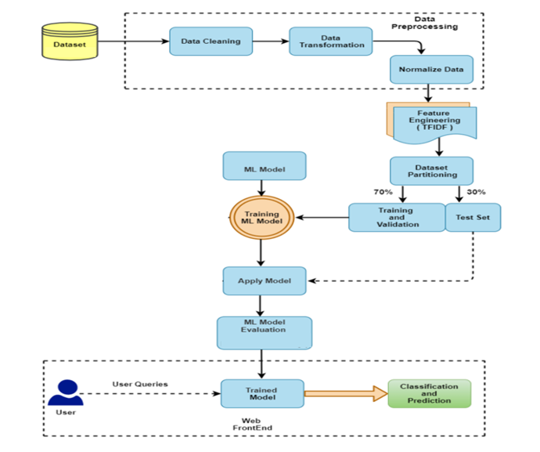

**Block diagram Description:**

To detect and classify YouTube comments as spam or not-spam, we have devised a comprehensive pipeline:

1. Data Cleaning: We begin by removing irrelevant and redundant data, ensuring comments are free from noise and anomalies.
2. Data Transforming: The comments are then transformed into a structured format, suitable for analysis.
3. Data Preprocessing: In data preprocessing for YouTube comments spam detection, several essential techniques are applied:

* 1. Tokenizer: Tokenization involves breaking down comments into individual words or tokens. This process allows the algorithm to work with individual words as features, making it easier to analyze the text.
* 2. Stemming: Stemming is the process of reducing words to their root or base form. It helps in treating words with the same root as identical, reducing the feature space and simplifying text analysis.
* 3. Lemmatization: Lemmatization is similar to stemming but considers the context to find a word's base form. It results in more accurate word representations, preserving the meaning of the words.
* 4. Vectorizer: Vectorization converts text data into numerical form. Techniques like TF-IDF (Term Frequency-Inverse Document Frequency) or word embeddings (e.g., Word2Vec or GloVe) are used to represent comments as numerical vectors, allowing machine learning models to process them.

4. Normalize the Data: We ensure uniformity in the dataset by scaling and normalizing the features.

5. Feature Engineering: Techniques like filling null values, label encoding, and leveraging NLP methods are employed to make the data more conducive for modeling.

6. Dataset Partitioning: The dataset is split into training (70%) and testing (30%) sets.

7. Machine Learning Modeling: Algorithms such as SVM-RBF, Random Forest, Extra Trees, and LSTM are implemented to discern patterns in the data.

8. Model Evaluation: The chosen models undergo rigorous evaluation to gauge their accuracy and efficiency.

9.Classification: The final model classifies comments into 'spam' or 'not-spam' categories.

10. Web Framework: An interactive website interface is built to showcase the project, allowing users to test the system's efficacy in real-time.

**4. REQUIREMENT ANALYSIS**

**4.1 Functional and non-functional requirements**

Requirement’s analysis is very critical process that enables the success of a system or software project to be assessed. Requirements are generally split into two types: Functional and non-functional requirements.

**Functional Requirements**: These are the requirements that the end user specifically demands as basic facilities that the system should offer. All these functionalities need to be necessarily incorporated into the system as a part of the contract. These are represented or stated in the form of input to be given to the system, the operation performed and the output expected. They are basically the requirements stated by the user which one can see directly in the final product, unlike the non-functional requirements.

Examples of functional requirements:

1. Authentication of user whenever he/she logs into the system
2. System shutdown in case of a cyber-attack
3. A verification email is sent to user whenever he/she register for the first time on some software system.

**Non-functional requirements**: These are basically the quality constraints that the system must satisfy according to the project contract. The priority or extent to which these factors are implemented varies from one project to other. They are also called non-behavioral requirements.  
They basically deal with issues like:

* Portability
* Security
* Maintainability
* Reliability
* Scalability
* Performance
* Reusability
* Flexibility

Examples of non-functional requirements:

1. Emails should be sent with a latency of no greater than 12 hours from such an activity.
2. The processing of each request should be done within 10 seconds
3. The site should load in 3 seconds whenever of simultaneous users are > 10000
   1. **Hardware Requirements**

# Processor - I3/Intel Processor

Hard Disk - 160GB

Key Board - Standard Windows Keyboard

Mouse - Two or Three Button Mouse

Monitor - SVGA

RAM - 8GB

* 1. **Software Requirements:**

Operating System : Windows 7/8/10

Server side Script : HTML, CSS, Bootstrap & JS

Programming Language : Python

Libraries : Flask, Pandas, Mysql.connector, Os, Numpy

IDE/Workbench : PyCharm ,Visual Studio code

Technology : Python 3.6+

Server Deployment : Xampp Server

Database : MySQL

* 1. **Architecture:**

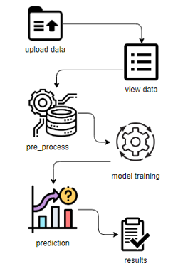

**ALGORITHMS**

* Support Vector Machine with Radial Basis Function kernel (SVM-RBF) is a machine learning algorithm used for classification and regression tasks. It employs a non-linear transformation to map data into a higher-dimensional space, where a hyperplane is established to maximize the margin between different classes. The Radial Basis Function kernel calculates similarity between data points, determining their influence on classification. This kernel's flexibility enables SVM-RBF to effectively handle complex, non-linear relationships in data. It's widely used for its ability to capture intricate patterns and achieve accurate results in various applications, such as image recognition, text categorization, and bioinformatics.
* Random Forest is a powerful machine learning algorithm that assembles multiple decision trees to make accurate predictions. Each tree is trained on a subset of data and votes on the final prediction, resulting in improved accuracy and robustness. It mitigates overfitting and handles complex relationships in data by averaging predictions from different trees. Random Forest is versatile, handling classification and regression tasks effectively. It's widely used due to its ability to capture intricate patterns in data, making it suitable for various domains such as finance, healthcare, and image analysis. Its ensemble nature enhances generalization and makes it a popular choice for predictive modeling.
* Extra Trees, short for Extremely Randomized Trees, is an ensemble machine learning algorithm used for classification and regression tasks. It's an extension of the Random Forest method, where multiple decision trees are built using bootstrapped samples and random feature subsets. However, Extra Trees takes randomness a step further by making decisions at each split point based on random thresholds, resulting in a broader exploration of feature space. This increases diversity among trees, reducing overfitting and improving generalization. By aggregating predictions from individual trees, Extra Trees enhances accuracy and robustness, making it suitable for complex datasets and improving overall predictive performance.
* Long Short-Term Memory (LSTM) is a specialized type of recurrent neural network (RNN) architecture in deep learning. It excels in processing and retaining sequential data by utilizing memory cells with various gates to regulate information flow. LSTMs are adept at capturing long-range dependencies, making them ideal for tasks like text analysis, speech recognition, and time series prediction. The architecture's key components include input, forget, and output gates, along with a cell state that can store and control information over extended sequences. This enables LSTMs to effectively model intricate patterns and relationships within sequential data, leading to enhanced performance in various applications.

**5. SYSTEM DESIGN**

**5.1 Introduction of Input Design:**

In an information system, input is the raw data that is processed to produce output. During the input design, the developers must consider the input devices such as PC, MICR, OMR, etc.

Therefore, the quality of system input determines the quality of system output. Well-designed input forms and screens have following properties −

* It should serve specific purpose effectively such as storing, recording, and retrieving the information.
* It ensures proper completion with accuracy.
* It should be easy to fill and straightforward.
* It should focus on user’s attention, consistency, and simplicity.
* All these objectives are obtained using the knowledge of basic design principles regarding −
  + What are the inputs needed for the system?
  + How end users respond to different elements of forms and screens.

### **Objectives for Input Design:**

The objectives of input design are −

* To design data entry and input procedures
* To reduce input volume
* To design source documents for data capture or devise other data capture methods
* To design input data records, data entry screens, user interface screens, etc.
* To use validation checks and develop effective input controls.

**Output Design:**

The design of output is the most important task of any system. During output design, developers identify the type of outputs needed, and consider the necessary output controls and prototype report layouts.

### Objectives of Output Design:

The objectives of input design are:

* To develop output design that serves the intended purpose and eliminates the production of unwanted output.
* To develop the output design that meets the end user’s requirements.
* To deliver the appropriate quantity of output.
* To form the output in appropriate format and direct it to the right person.
* To make the output available on time for making good decisions.

**5.2 UML DIAGRAMS**

UML stands for Unified Modelling Language. UML is a standardized general-purpose modelling language in the field of object-oriented software engineering. The standard is managed, and was created by, the Object Management Group.

The goal is for UML to become a common language for creating models of object-oriented computer software. In its current form UML is comprised of two major components: a Meta-model and a notation. In the future, some form of method or process may also be added to; or associated with, UML.

The Unified Modelling Language is a standard language for specifying, Visualization, Constructing and documenting the artefacts of software system, as well as for business modelling and other non-software systems.

The UML represents a collection of best engineering practices that have proven successful in the modelling of large and complex systems.

The UML is a very important part of developing objects-oriented software and the software development process. The UML uses mostly graphical notations to express the design of software projects.

**GOALS:**

The Primary goals in the design of the UML are as follows:

1. Provide users a ready-to-use, expressive visual modelling Language so that they can develop and exchange meaningful models.
2. Provide extendibility and specialization mechanisms to extend the core concepts.
3. Be independent of particular programming languages and development process.
4. Provide a formal basis for understanding the modelling language.
5. Encourage the growth of OO tools market.
6. Support higher level development concepts such as collaborations, frameworks, patterns and components.
7. Integrate best practices.

**USE CASE DIAGRAM**

* A use case diagram in the Unified Modeling Language (UML) is a type of behavioral diagram defined by and created from a Use-case analysis.
* Its purpose is to present a graphical overview of the functionality provided by a system in terms of actors, their goals (represented as use cases), and any dependencies between those use cases.
* The main purpose of a use case diagram is to show what system functions are performed for which actor. Roles of the actors in the system can be depicted.

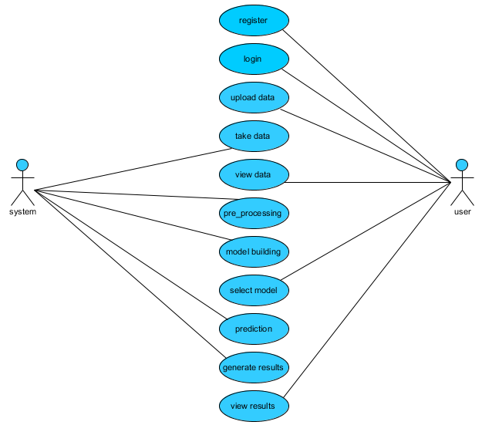

**CLASS DIAGRAM**

In software engineering, a class diagram in the Unified Modeling Language (UML) is a type of static structure diagram that describes the structure of a system by showing the system's classes, their attributes, operations (or methods), and the relationships among the classes. It explains which class contains information

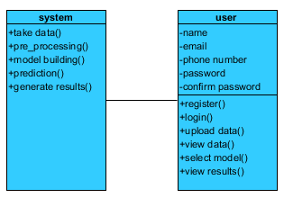

**SEQUENCE DIAGRAM**

* A sequence diagram in Unified Modeling Language (UML) is a kind of interaction diagram that shows how processes operate with one another and in what order.
* It is a construct of a Message Sequence Chart. Sequence diagrams are sometimes called event diagrams, event scenarios, and timing diagrams

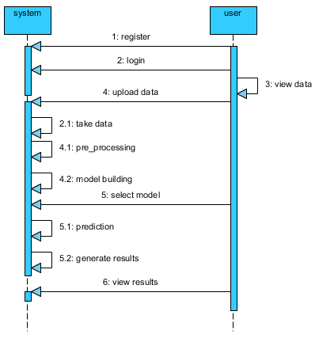

**COLLABORATION DIAGRAM:**

In collaboration diagram the method call sequence is indicated by some numbering technique as shown below. The number indicates how the methods are called one after another. We have taken the same order management system to describe the collaboration diagram. The method calls are similar to that of a sequence diagram. But the difference is that the sequence diagram does not describe the object organization whereas the collaboration diagram shows the object organization.

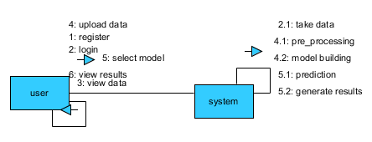

**DEPLOYMENT DIAGRAM**

Deployment diagram represents the deployment view of a system. It is related to the component diagram. Because the components are deployed using the deployment diagrams. A deployment diagram consists of nodes. Nodes are nothing but physical hardware’s used to deploy the application.

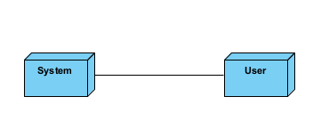

**ACTIVITY DIAGRAM:**

Activity diagrams are graphical representations of workflows of stepwise activities and actions with support for choice, iteration and concurrency. In the Unified Modelling Language, activity diagrams can be used to describe the business and operational step-by-step workflows of components in a system. An activity diagram shows the overall flow of control.

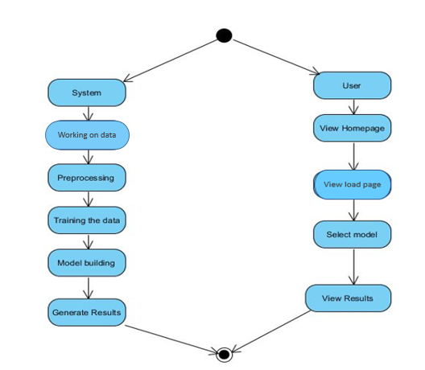

**COMPONENT DIAGRAM**:

A component diagram, also known as a UML component diagram, describes the organization and wiring of the physical **c**omponents in a system. Component diagrams are often drawn to help model implementation details and double-check that every aspect of the system's required function is covered by planned development.

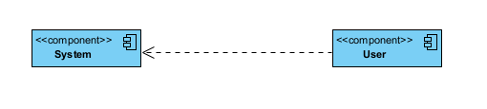

**ER DIAGRAM:**

An Entity–relationship model (ER model) describes the structure of a database with the help of a diagram, which is known as Entity Relationship Diagram (ER Diagram). An ER model is a design or blueprint of a database that can later be implemented as a database. The main components of E-R model are: entity set and relationship set.

An ER diagram shows the relationship among entity sets. An entity set is a group of similar entities and these entities can have attributes. In terms of DBMS, an entity is a table or attribute of a table in database, so by showing relationship among tables and their attributes, ER diagram shows the complete logical structure of a database. Let’s have a look at a simple ER diagram to understand this concept.

# 

**DFD DIAGRAM:**

A Data Flow Diagram (DFD) is a traditional way to visualize the information flows within a system. A neat and clear DFD can depict a good amount of the system requirements graphically. It can be manual, automated, or a combination of both. It shows how information enters and leaves the system, what changes the information and where information is stored. The purpose of a DFD is to show the scope and boundaries of a system as a whole. It may be used as a communications tool between a systems analyst and any person who plays a part in the system that acts as the starting point for redesigning a system.

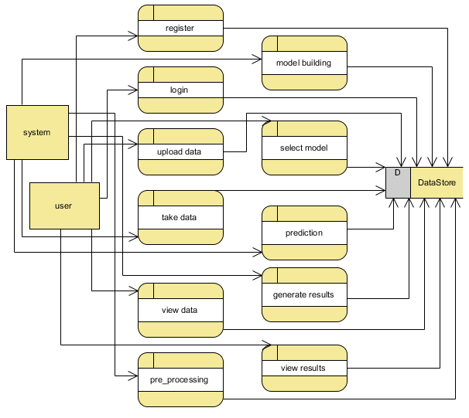

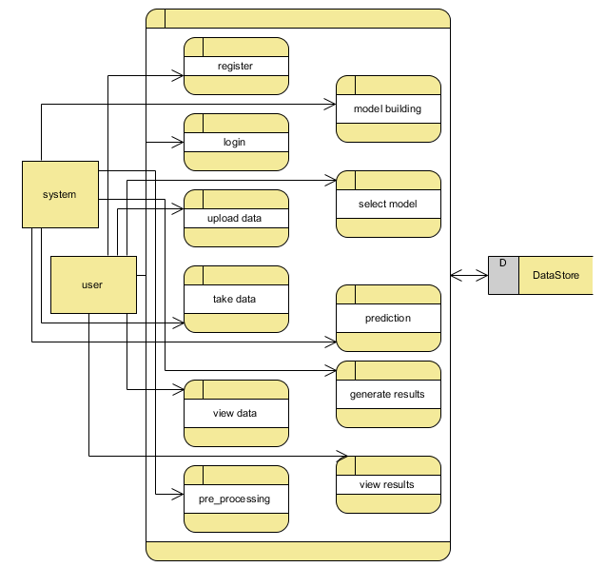

**6. IMPLEMENTATION**

* **6.1 MODULES:**

1. **User**:
   1. **View Home page:**

Here user view the home page of the You tube application.

* 1. **View about page:**

In the about page, users can learn more about the You tube platform.

**View Page:**

User will see the dataset.

* 1. **Input Model:**

The user must provide input values for the certain fields in order to get results.

* 1. **View Results:**

User view’s the generated results from the model.

* 1. **View score:**

Here user have ability to view the accuracy score in %

**Graph:**

Comparison of accuracy foe every models

1. **System**
   1. **Working on dataset:**

System checks for data whether it is available or not and load the data in csv files.

* 1. **Pre-processing:**

Data need to be pre-processed according the models it helps to increase the accuracy of the model and better information about the data.

* 1. **Training the data:**

After pre-processing the data will split into two parts as train and test data before training with the given algorithms.

* 1. **Model Building**

To create a model that predicts the dataset with better accuracy, this module will help user.

* 1. **Generated Score:**
  2. Here user view the score in %
  3. **Generate Results:**

We train the machine learning algorithm and predict the result.

**8. SYSTEM STUDY AND TESTING**

**8.1 Feasibility Study**

The feasibility of the project is analysed in this phase and business proposal is put forth with a very general plan for the project and some cost estimates. During system analysis the feasibility study of the proposed system is to be carried out. This is to ensure that the proposed system is not a burden to the company. For feasibility analysis, some understanding of the major requirements for the system is essential.

Three key considerations involved in the feasibility analysis are

* Economical feasibility
* Technical feasibility
* Social feasibility

**Economical Feasibility**

This study is carried out to check the economic impact that the system will have on the organization. The amount of fund that the company can pour into the research and development of the system is limited. The expenditures must be justified. Thus the developed system as well within the budget and this was achieved because most of the technologies used are freely available. Only the customized products had to be purchased.

### **Technical Feasibility**

This study is carried out to check the technical feasibility, that is, the technical requirements of the system. Any system developed must not have a high demand on the available technical resources. This will lead to high demands on the available technical resources. This will lead to high demands being placed on the client. The developed system must have a modest requirement, as only minimal or null changes are required for implementing this system.

**Social Feasibility**

The aspect of study is to check the level of acceptance of the system by the user. This includes the process of training the user to use the system efficiently. The user must not feel threatened by the system, instead must accept it as a necessity. The level of acceptance by the users solely depends on the methods that are employed to educate the user about the system and to make him familiar with it. His level of confidence must be raised so that he is also able to make some constructive criticism, which is welcomed, as he is the final user of the system.

**System Testing**

The purpose of testing is to discover errors. Testing is the process of trying to discover every conceivable fault or weakness in a work product. It provides a way to check the functionality of components, sub-assemblies, assemblies and/or a finished product It is the process of exercising software with the intent of ensuring that the

Software system meets its requirements and user expectations and does not fail in an unacceptable manner. There are various types of test. Each test type addresses a specific testing requirement.

**8.2 Types of Tests**

**8.2.1 Unit testing**

Unit testing involves the design of test cases that validate that the internal program logic is functioning properly, and that program inputs produce valid outputs. All decision branches and internal code flow should be validated. It is the testing of individual software units of the application .it is done after the completion of an individual unit before integration. This is a structural testing, that relies on knowledge of its construction and is invasive. Unit tests perform basic tests at component level and test a specific business process, application, and/or system configuration. Unit tests ensure that each unique path of a business process performs accurately to the documented specifications and contains clearly defined inputs and expected results.

**8.2.2 Integration testing**

Integration tests are designed to test integrated software components to determine if they actually run as one program. Testing is event driven and is more concerned with the basic outcome of screens or fields. Integration tests demonstrate that although the components were individually satisfaction, as shown by successfully unit testing, the combination of components is correct and consistent. Integration testing is specifically aimed at exposing the problems that arise from the combination of components.

Software integration testing is the incremental integration testing of two or more integrated software components on a single platform to produce failures caused by interface defects.

The task of the integration test is to check that components or software applications, e.g. components in a software system or – one step up – software applications at the company level – interact without error.

**Test Results:** All the test cases mentioned above passed successfully. No defects encountered.

**Acceptance Testing**

User Acceptance Testing is a critical phase of any project and requires significant participation by the end user. It also ensures that the system meets the functional requirements.

**Test Results:** All the test cases mentioned above passed successfully. No defects encountered.

**8.2.3 Functional testing**

Functional tests provide systematic demonstrations that functions tested are available as specified by the business and technical requirements, system documentation, and user manuals.

Functional testing is centered on the following items:

Valid Input : identified classes of valid input must be accepted.

Invalid Input : identified classes of invalid input must be rejected.

Functions : identified functions must be exercised.

Output : identified classes of application outputs must be exercised.

Systems/Procedures: interfacing systems or procedures must be invoked.

Organization and preparation of functional tests is focused on requirements, key functions, or special test cases. In addition, systematic coverage pertaining to identify Business process flows; data fields, predefined processes, and successive processes must be considered for testing. Before functional testing is complete, additional tests are identified and the effective value of current tests is determined.

**9.2.4 White Box Testing**

White Box Testing is a testing in which in which the software tester has knowledge of the inner workings, structure and language of the software, or at least its purpose. It is purpose. It is used to test areas that cannot be reached from a black box level.

**9.2.5 Black Box Testing**

Black Box Testing is testing the software without any knowledge of the inner workings, structure or language of the module being tested. Black box tests, as most other kinds of tests, must be written from a definitive source document, such as specification or requirements document, such as specification or requirements document. It is a testing in which the software under test is treated, as a black box .you cannot “see” into it. The test provides inputs and responds to outputs without considering how the software works.

**Test objectives**

* All field entries must work properly.
* Pages must be activated from the identified link.
* The entry screen, messages and responses must not be delayed.

**Features to be tested**

* Verify that the entries are of the correct format
* No duplicate entries should be allowed
* All links should take the user to the correct page.

1. **CONCLUSION**

In our study on YouTube spam detection using machine learning, we employed a diverse set of models, including SVM with the RBF kernel, RandomForest, LSTM (Long Short-Term Memory), and ExtraTreesClassifier, to tackle the critical issue of identifying spam comments within YouTube's vast dataset of user comments. Our findings revealed that these models exhibited varying levels of accuracy, precision, and recall in distinguishing between genuine user comments and spam. While the LSTM demonstrated promising results by capturing temporal dependencies in text data, other models such as RandomForest and ExtraTreesClassifier excelled in feature selection and ensemble-based classification. These outcomes underscore the complexity of spam detection in a dynamic online platform like YouTube. Our research contributes to enhancing user experience and content quality by automating the identification and removal of spam, ultimately making online communities safer and more engaging. Further refinements and advancements in machine learning techniques hold the potential for even more robust spam detection systems in the future.

1. **FUTURE ENHANCEMENT**

The future scope of Machine Learning-based Spam Comments Detection on YouTube involves enhancing model robustness through advanced deep learning techniques, incorporating sentiment analysis for context-aware detection, real-time monitoring with automated moderation, and leveraging user feedback for continuous improvement. Additionally, exploring multi-modal approaches integrating text, audio, and video analysis could further elevate accuracy in identifying evolving spam tactics, contributing to a safer and more engaging user experience on the platform.

**11.REFERENCES**

[1] Sah, U. K., & Parmar, N. (2017). An approach for Malicious Spam Detection in Email with comparison of different classifiers.

[2]Alberto, T. C., Lochter, J. V., & Almeida, T. A. (2015, December). Tubespam: Comment spam filtering on youtube. In Machine Learning and Applications (ICMLA), 2015 IEEE 14th International Conference on (pp. 138-143). IEEE.

[3] Alsaleh, M., Alarifi, A., Al-Quayed, F., & Al-Salman, A. (2016). Combating comment spam with machine learning approaches. Proceedings - 2015 IEEE 14th International Conference on Machine Learning and Applications, ICMLA 2015, 295–300. <https://doi.org/10.1109/ICMLA.2015.192>

[4] Scheltus, P., Dorner, V., & Lehner, F. (2013). Leave a Comment! An In-Depth Analysis of User Comments on YouTube. Wirtschaftsinformatik, 42.

[5] A. Kantchelian, J. Ma, L. Huang, S. Afroz, A. Joseph, J. D. Tygar, Robust detection of comment spam using entropy rate, in: Proceedings of the 5th ACM Workshop on Security and Artificial Intelligence, AISec ‘12, ACM, New York, NY, USA, 2012, pp. 59-70. doi:10.1145/2381896.2381907.

[6] S. Aiyar and N. P. Shetty, "N-gram assisted Youtube spam comment detection", Proc. Comput. Sci., vol. 132, pp. 174-182, Jan. 2018.

[7] A. Kantchelian, J. Ma, L. Huang, S. Afroz, A. Joseph and J. D. Tygar, "Robust detection of comment spam using entropy rate", Proc. 5th ACM Workshop Secur. Artif. Intell. (AISec), pp. 59-70, 2012.

[8] A. Madden, I. Ruthven and D. Mcmenemy, "A classification scheme for content analyses of Youtube video comments", J. Documentation, vol. 69, no. 5, pp. 693-714, Sep. 2013.

[9] A. Severyn, A. Moschitti, O. Uryupina, B. Plank and K. Filippova, "Opinion mining on Youtube", Proc. 52nd Annu. Meeting Assoc. Comput. Linguistics (Long Papers), vol. 1, pp. 1-10, 2014.

[10] M. Z. Asghar, S. Ahmad, A. Marwat and F. M. Kundi, "Sentiment analysis on Youtube: A brief survey", arXiv:1511.09142, 2015, [online] Available: http://arxiv.org/abs/1511.09142